**Name**:Eslam Ali Hassan Mohamed

**B.N/**2166120200101133

**Date**: 6-6-2021

**Topic**: Operating Systems

**Application Brief**: By any standard of measure, an operating system is the most critical software installed on a computer. Not only does an operating system act as the administrator of many computer processes, but it also allows users to harness the power of the various sound, graphics and memory assets within the computer's hardware infrastructure. For the vast majority of users today, a computer would be useless if it did not include some form of an operating system.

**GitHub-Link:**

https**:**[//github.com/eslam548/html-project0-repository](https://github.com/eslam548/html-project0-repository)

**GitHub-Page(Published Website):**

<https://eslam548.github.io/html-project0-repository/figure.html>

**Screenshots**:

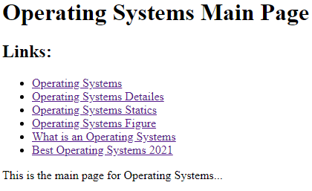

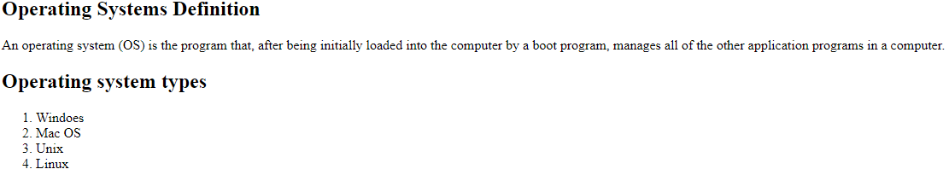

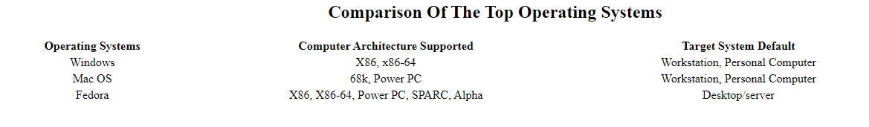

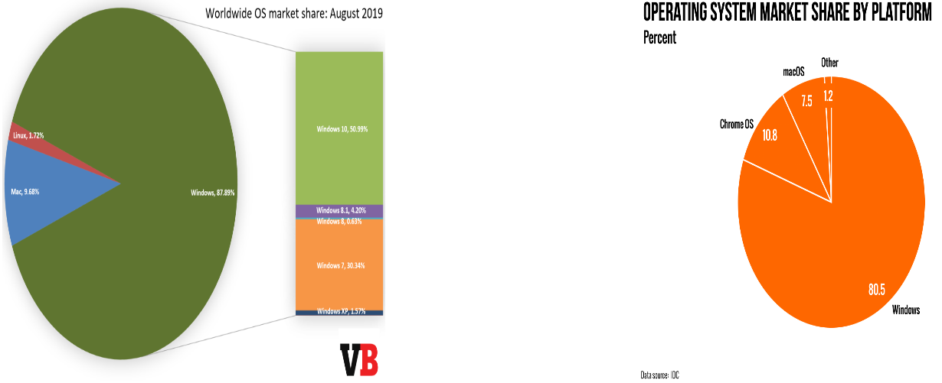

**Source Code**:

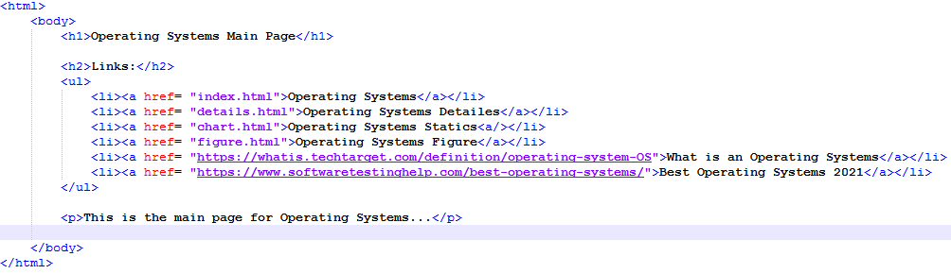

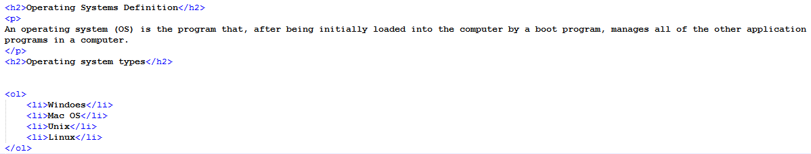

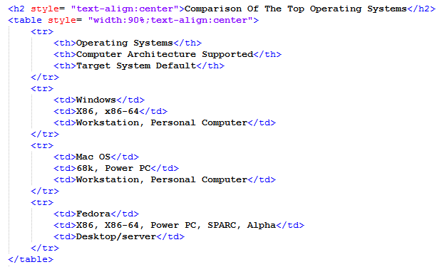

8